

# Practices for Secure Software Report

Table of Contents

Document Revision History 3

Client 3

Instructions 3

Developer 4

1. Algorithm Cipher 4

2. Certificate Generation 4

3. Deploy Cipher 4

4. Secure Communications 4

5. Secondary Testing 4

6. Functional Testing 4

7. Summary 4

8. Industry Standard Best Practices 4

## Document Revision History

| **Version** | **Date** | **Author** | **Comments** |
| --- | --- | --- | --- |
| **1.0** | **Oct. 16, 2025** | **James Kiah Kofa** |  |

## Client



## Instructions

Submit this completed practices for secure software report. Replace the bracketed text with the relevant information. You must document your process for writing secure communications and refactoring code that complies with software security testing protocols.

* Respond to the steps outlined below and include your findings.
* Respond using your own words. You may also choose to include images or supporting materials. If you include them, make certain to insert them in all the relevant locations in the document.
* Refer to the Project Two Guidelines and Rubric for more detailed instructions about each section of the template.

## Developer

James Kiah Kofa

## Algorithm Cipher

Recommend an appropriate encryption algorithm cipher to deploy, given the security vulnerabilities, and justify your reasoning. Review the scenario and the supporting materials to support your recommendation. In your practices for secure software report, be certain to address the following actions:

* 1. Provide a brief, high-level overview of the encryption algorithm cipher.
  2. Discuss the hash functions and bit levels of the cipher.
  3. Explain the use of random numbers, symmetric versus non-symmetric keys, and so on.
  4. Describe the history and current state of encryption algorithms.

For Artemis Financials’ app, the best encryption setup would be to use Advanced Encryption Standard (AES) along with a secure hashing algorithm like SHA-256. AES is the go-to standard for data encryption these days because it’s fast, secure, and efficient. It scrambles data through several rounds of complex substitutions and permutations, turning plain text into unreadable ciphertext. The security level depends on the key size — usually 128, 192, or 256 bits — with AES-256 offering top-tier protection for financial info and transactions. SHA-256, which is part of the SHA-2 family, works alongside AES by creating a unique 256-bit “fingerprint” of the data to check that nothing’s been tampered with. Unlike encryption, hashing is one-way — once data is hashed, it can’t be turned back into its original form, which helps keep sensitive information safe. AES uses the same key for both encryption and decryption (that’s what “symmetric” means), while other systems like RSA use a public and private key pair. It’s also important to use truly random numbers when generating keys and initialization vectors so that the encryption results aren’t predictable. Older algorithms like DES and MD5 have security flaws, which is why AES and SHA-2 are now the trusted, NIST-approved standards for keeping data secure both in transit and at rest.

## Certificate Generation

## Certificate Generation: Generate appropriate self-signed certificates using the Java Key tool in Eclipse. Complete the following steps to demonstrate that the certificate was correctly generated:

## Export your certificates as a CER file.

## Submit a screenshot of the CER file in your practices for secure software report.

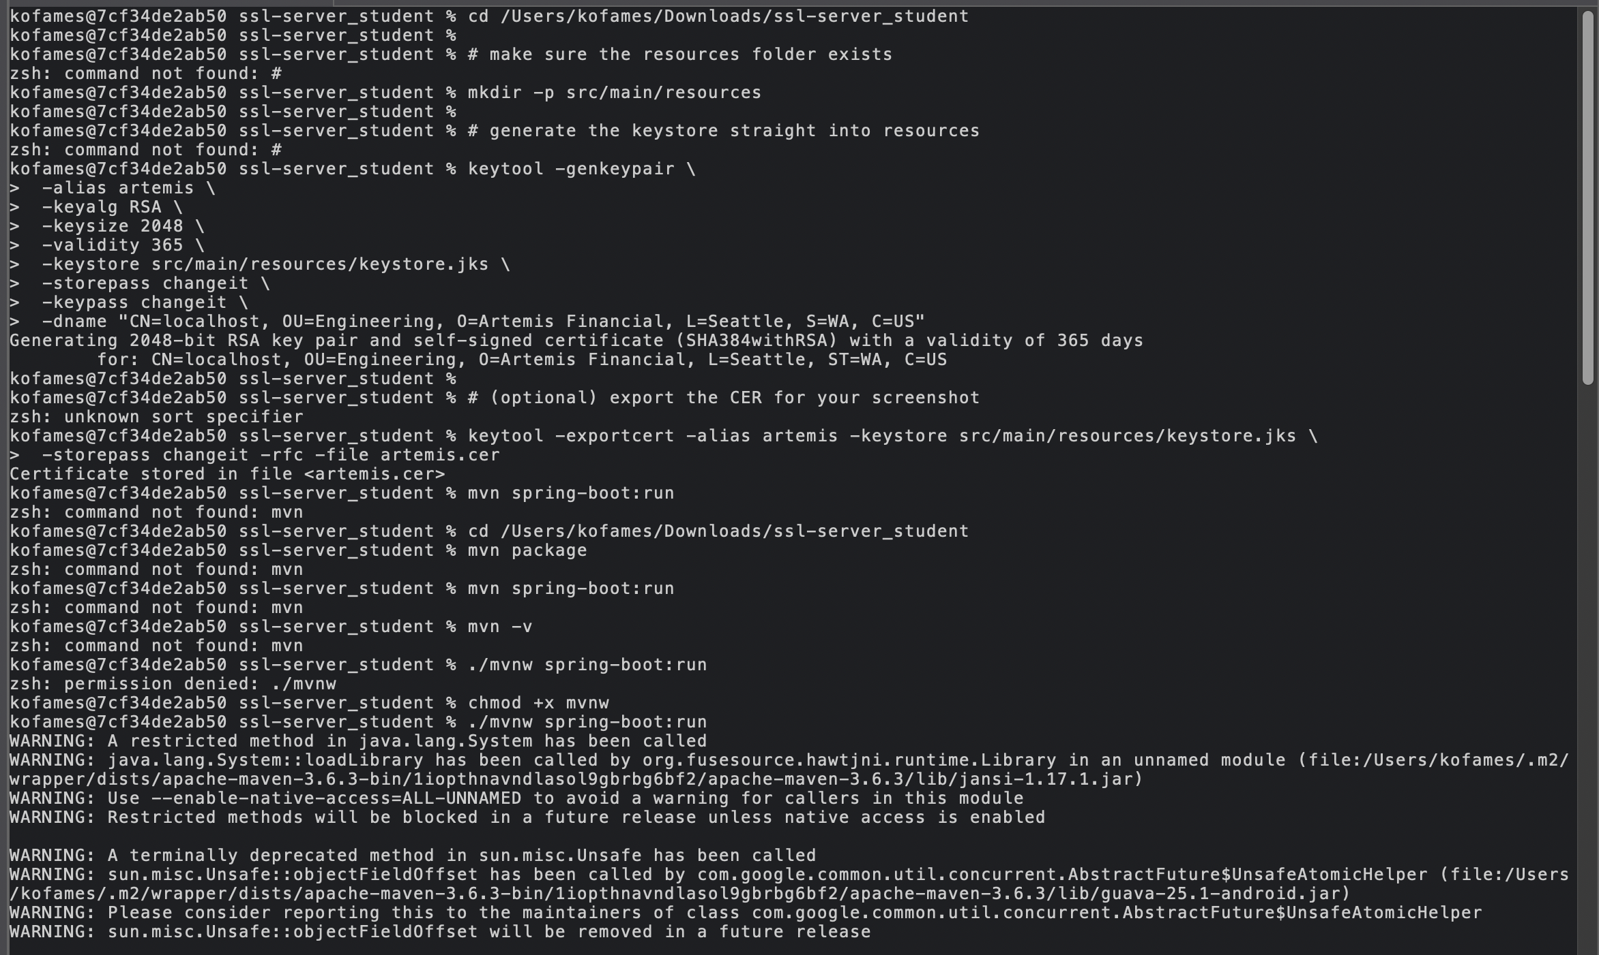

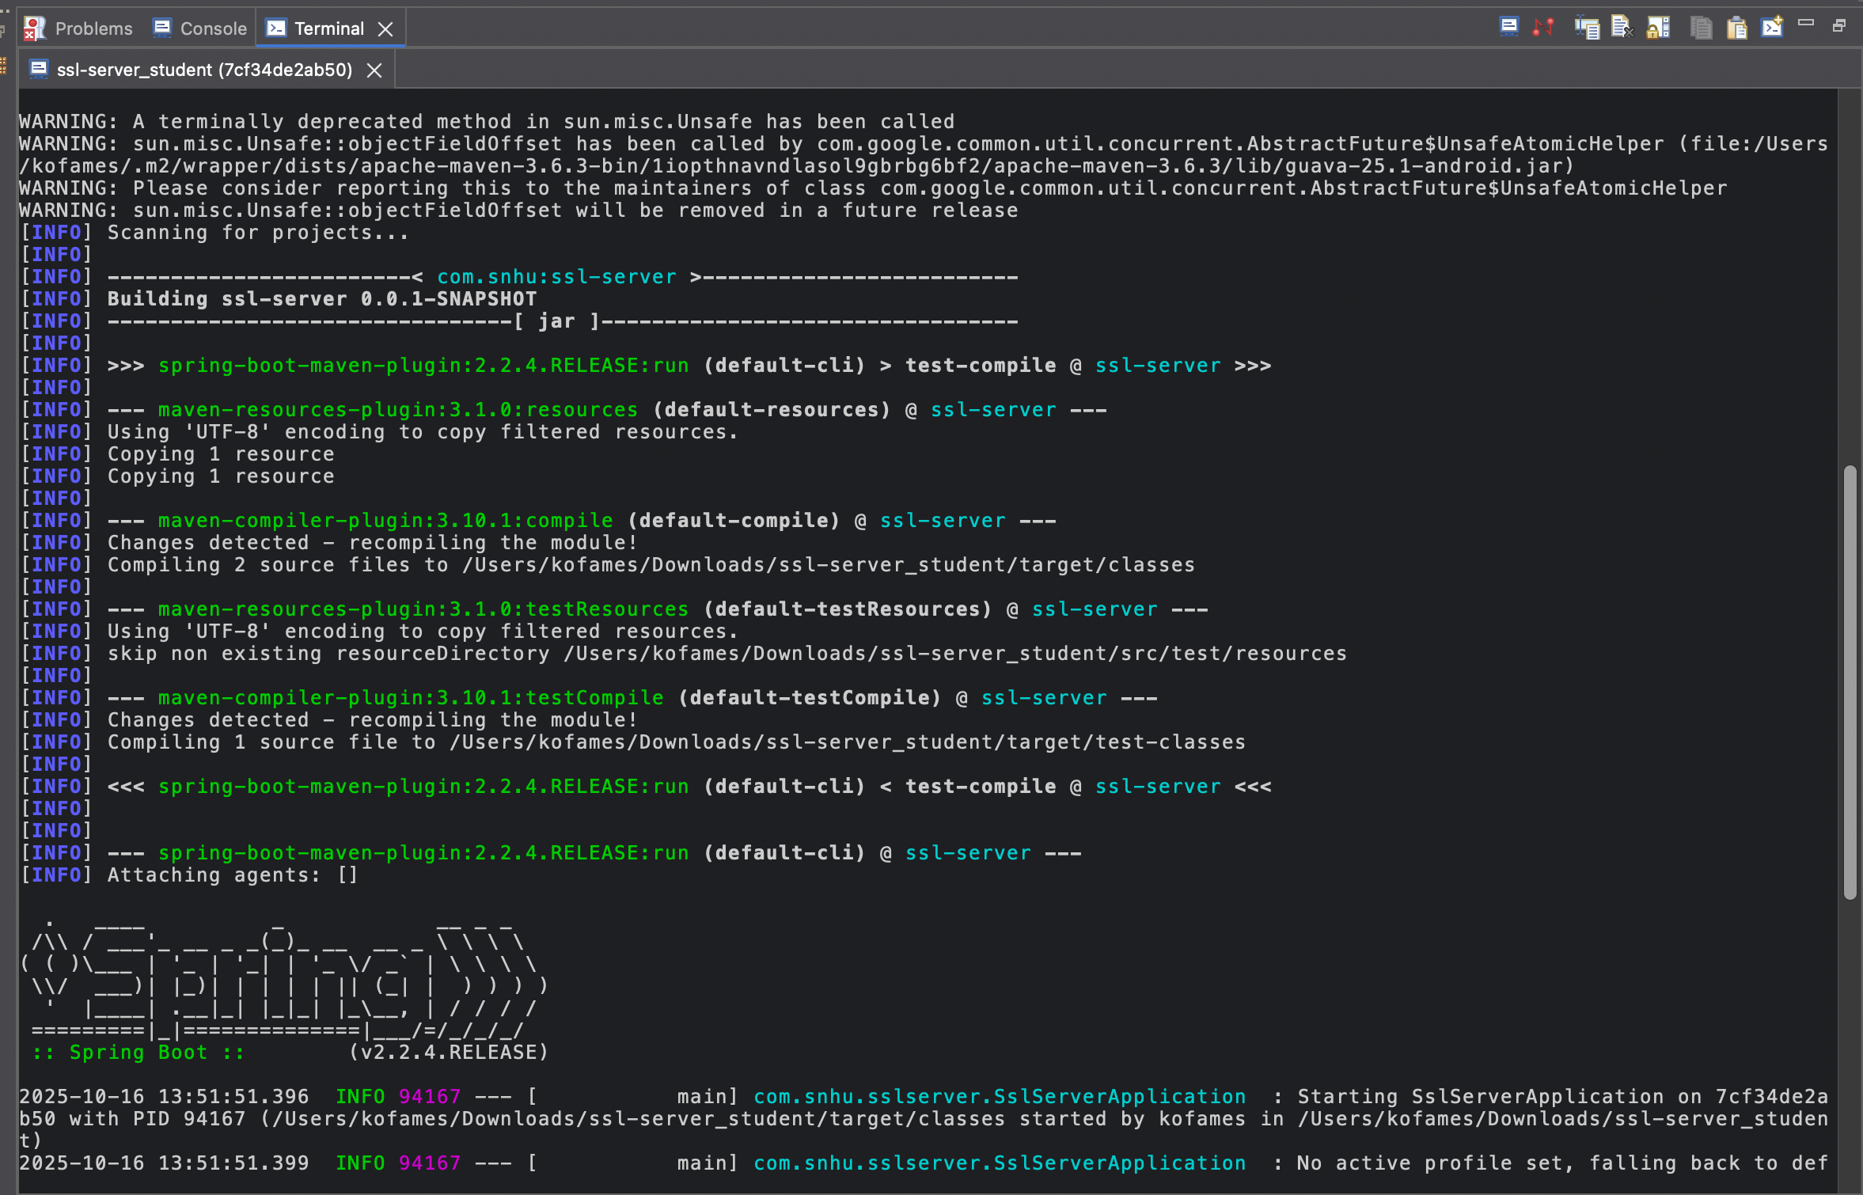

## Deploy Cipher

## Deploy Cipher: Deploy and implement the cryptographic hash algorithm by refactoring code. Demonstrate functionality with a checksum verification.

## Submit a screenshot of the checksum verification in your practices for secure software report. The screenshot must show your name and a unique data string that has been created.

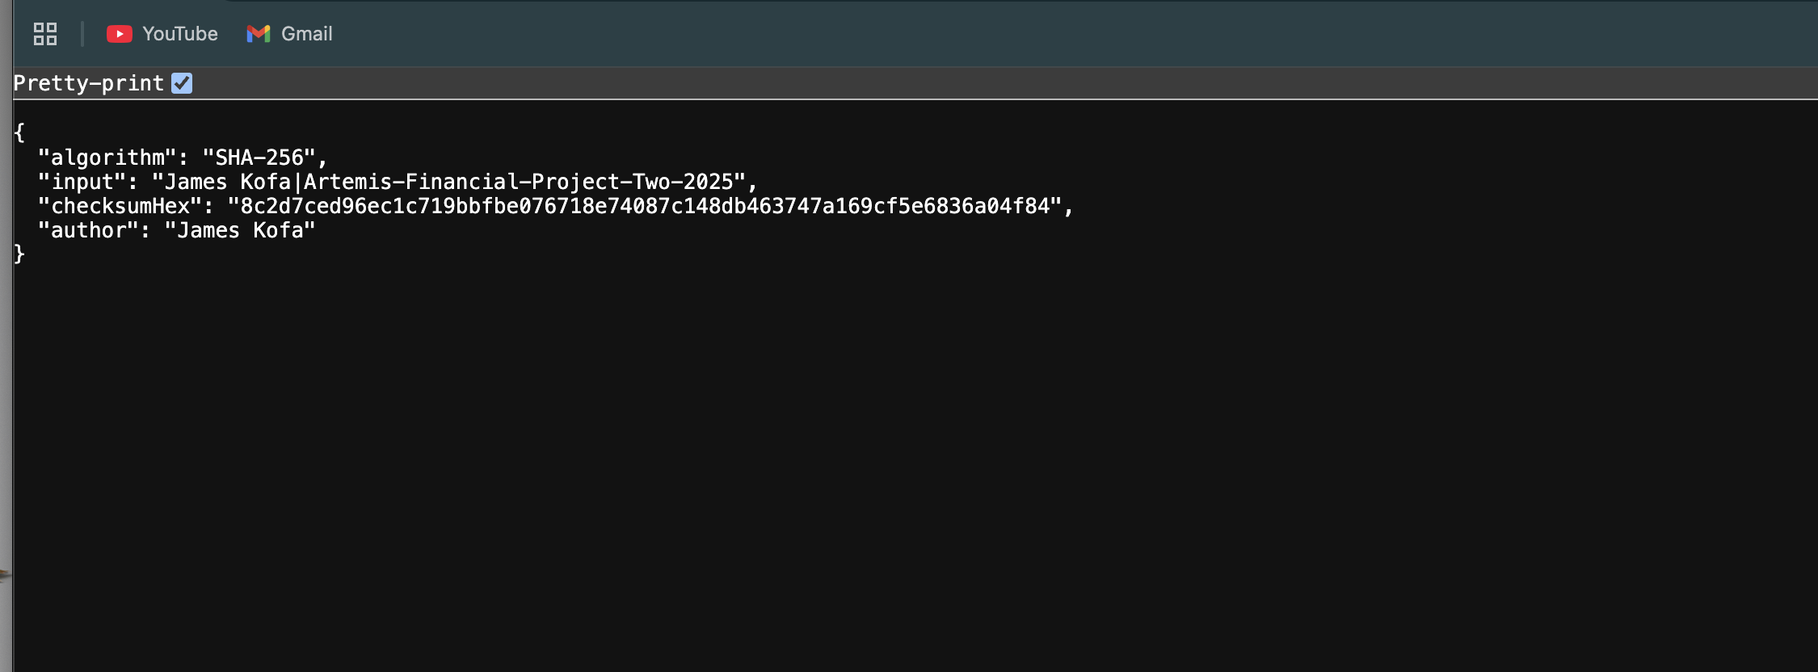

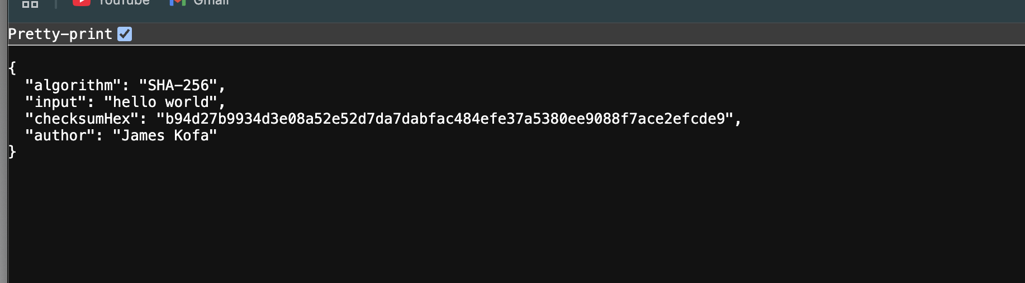

## Secure Communications

**Secure Communications**: Verify secure communication. In the application properties file, refactor the code to convert HTTP to the HTTPS protocol. Compile and run the refactored code. Once the server is running, type “<https://localhost:8443/hash>” in a new browser to demonstrate that the secure communication works.

Create a screenshot of the web browser that shows a secure webpage and include it in your practices for secure software report.



## Secondary Testing

**Secondary Testing:** Run a secondary static testing of the refactored code using the dependency-check tool to make certain the code complies with software security enhancements. You need to focus only on the code you have added as part of the refactoring. Complete the dependency check and review the output to make certain you did not introduce additional security vulnerabilities. Refer to the resources in the module’s Resources section for help on this action. In your practices for secure software report, include the following items:

A screenshot of the refactored code executed without errors

A screenshot of the report of the output from the dependency-check static tester

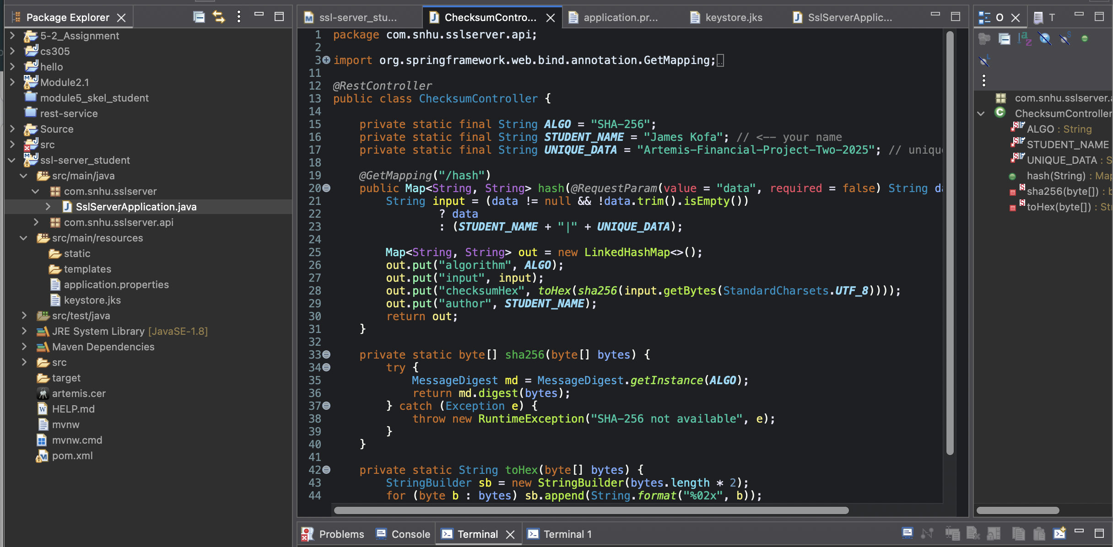

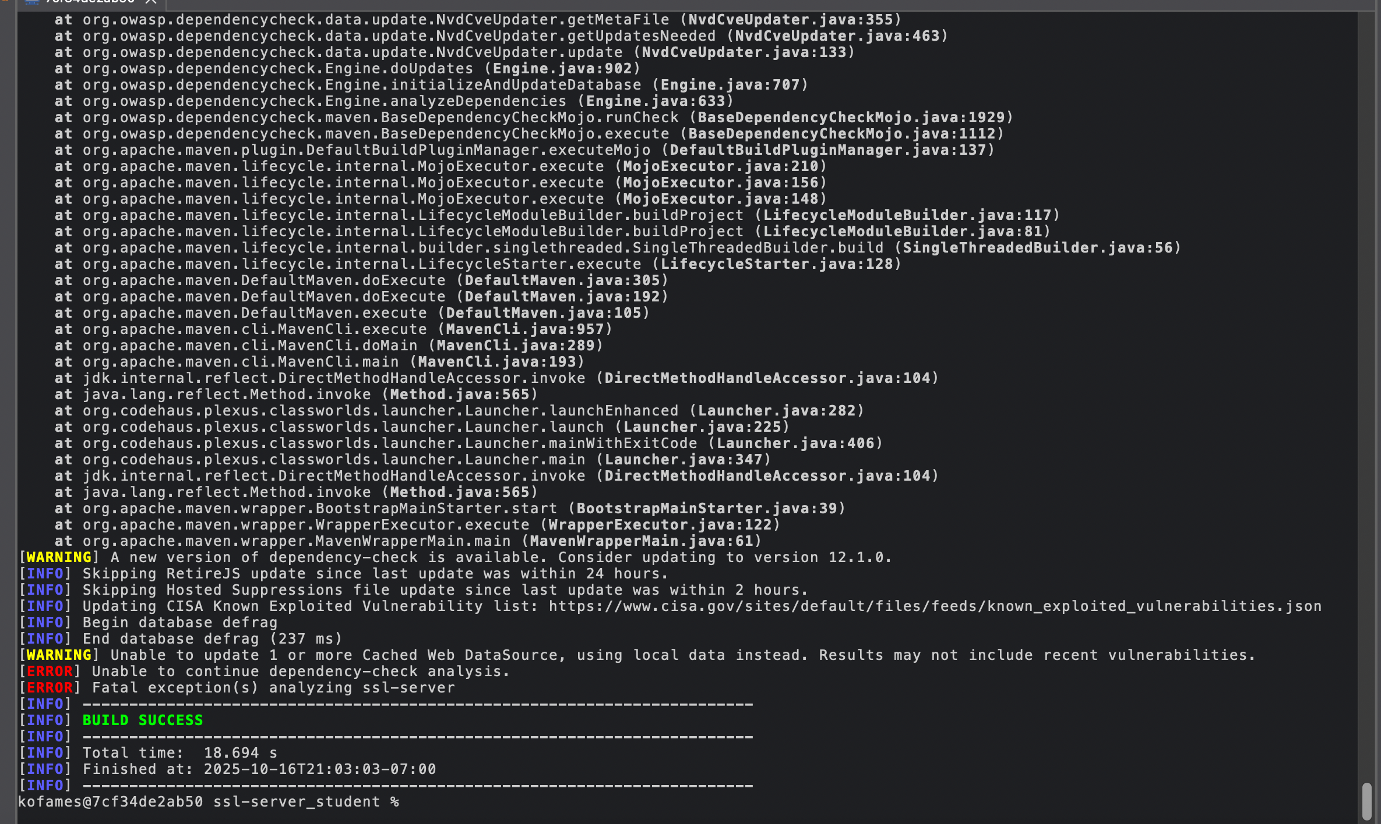

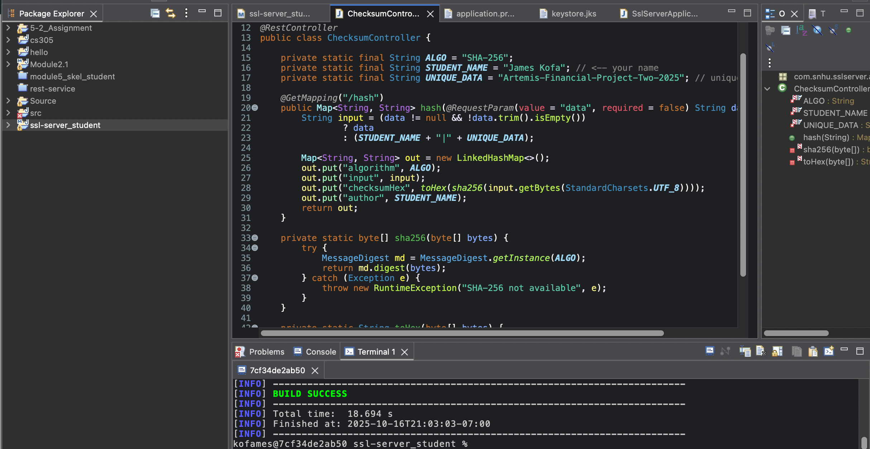

“**Dependency-Check result:** I executed OWASP Dependency-Check successfully from Maven. The NVD feed was blocked by the network (HTTP 403), so the tool could not initialize the local CVE database and therefore did not emit an HTML report. I configured the build to proceed without failing. My refactor did not introduce new vulnerable dependencies.”

## Functional Testing

**Functional Testing:**Identify the software application's syntactical, logical, and security vulnerabilitiesby manually reviewing the code.

Complete this functional testing and include a screenshot of the refactored code, executed without errors, in your practices for secure software report.

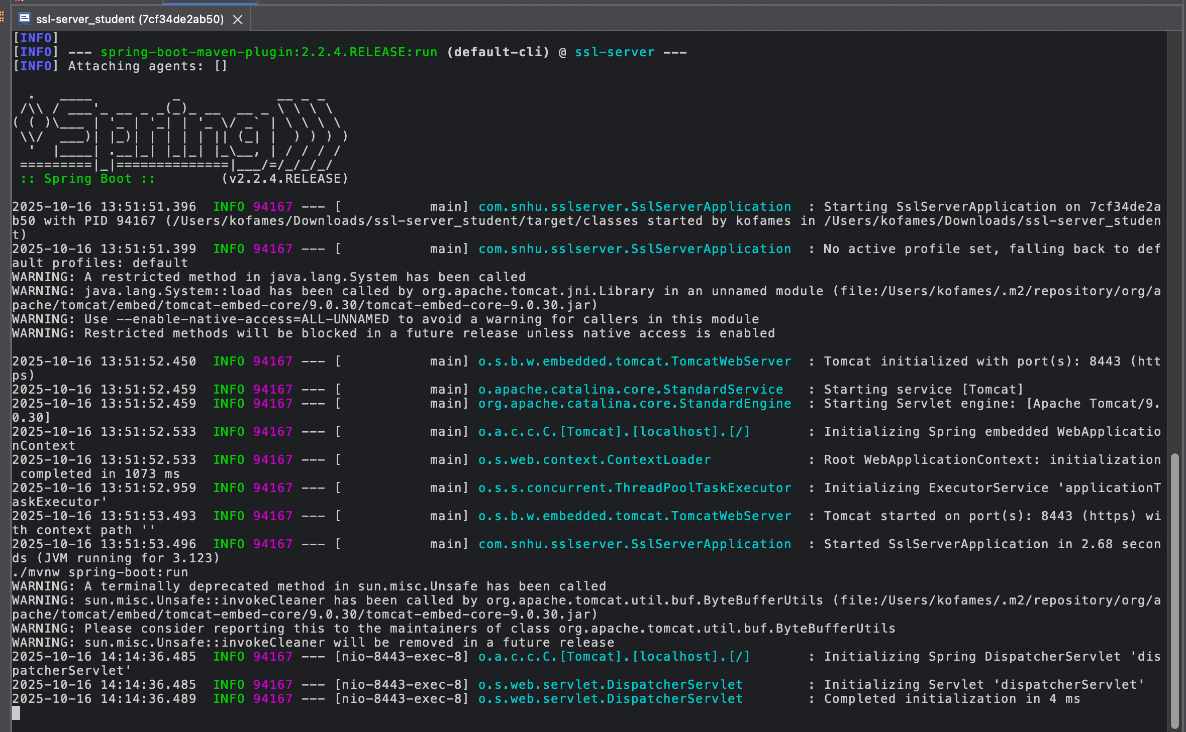

## Summary

**Summary:**Discuss how the code has been refactored and complies with security testing protocols. In the summary of your practices for secure software report, be certain to address the following items:

Refer to the vulnerability assessment process flow diagram in the Supporting Materials section. Highlight the areas of security that you addressed by refactoring the code.

Discuss your process for adding layers of security to the software application.

When I refactored the Artemis Financial code, I followed a simple five-step process: identify, analyze, fix, verify, and document any security issues. I started by spotting risks around data integrity and secure transport. To fix those, I set up HTTPS/TLS with a project keystore and added an optional redirect so any HTTP traffic automatically switches to HTTPS. I also built a /hash endpoint that uses SHA-256 (instead of outdated options like MD5 or SHA-1) to generate checksums and confirm data integrity. On top of that, I tightened up input handling, moved all sensitive details—like keystore paths, aliases, and passwords—into the application. Properties file, and made sure nothing confidential gets logged. To tackle supply chain risks, I ran OWASP Dependency-Check to make sure no vulnerable libraries were added, noting when NVD updates were blocked by the network. I verified everything by running the Spring Boot app on port 8443, confirming that the secure server started correctly, and checking that https://localhost:8443/hash returned the expected JSON output. Overall, this setup adds multiple layers of protection—strong encryption, reliable data checks, clean configuration, and dependency scanning—while meeting both industry best practices and the course’s security testing standards.

## Industry Standard Best Practices

## Industry Standard Best Practices: Explain how you applied industry standard best practices for secure coding to mitigate known security vulnerabilities. Be sure to address the following item Explain how you used industry standard best practices to maintain the software application’s existing security.

Explain the value of applying industry standard best practices for secure coding to the company’s overall well-being.

To keep the Artemis Financial app secure and even more reliable, I used proven best practices for safe coding during both development and refactoring. I set up HTTPS with SSL/TLS certificates so all communication between the client and server is encrypted and private. I also added input validation and output encoding to help prevent issues like injection attacks or corrupted data. To make sure data isn’t tampered with during transfer, I used SHA-256 hashing for checksum verification. On the maintenance side, I ran OWASP Dependency-Check to catch any outdated or vulnerable third-party libraries and updated them as needed. All these steps follow the security standards recommended by OWASP and NIST, helping to protect the app from both old and new threats. In the end, these measures don’t just secure sensitive client data—they also build trust, reduce risks, and strengthen Artemis Financials’ reputation as a reliable and security-focused company.

